Dynamic Routing - Project Worksheet
 | Points Possible | Points Awarded
- Configure IP addresses and enable the necessary interfaces on R3
- gi0/0 – 192.168.99.9/30
- gi0/1 – 192.168.99.6/30
- gi0/2 – 192.168.4.1/24
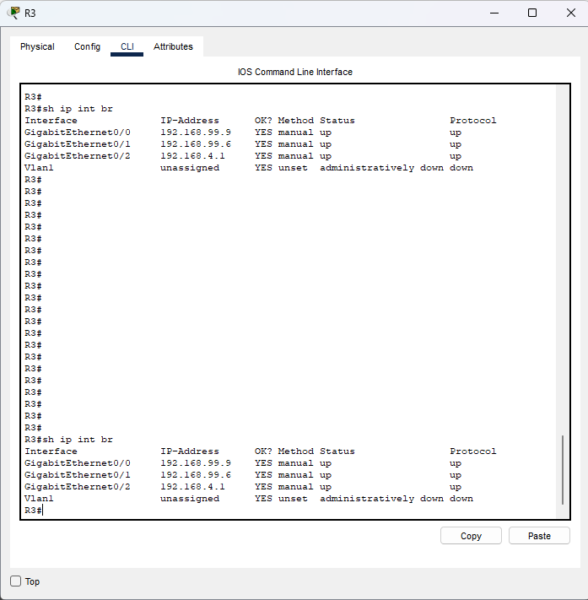 | 1
- Configure the interior routers using EIGRP.
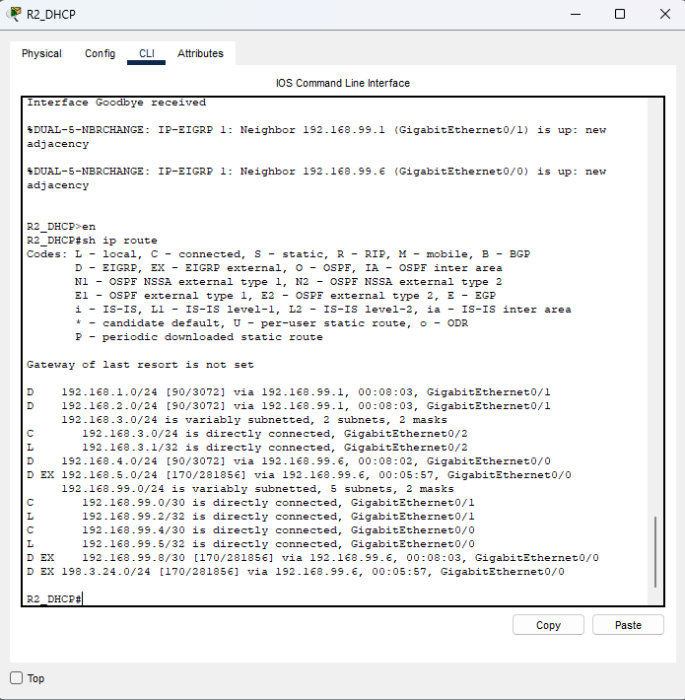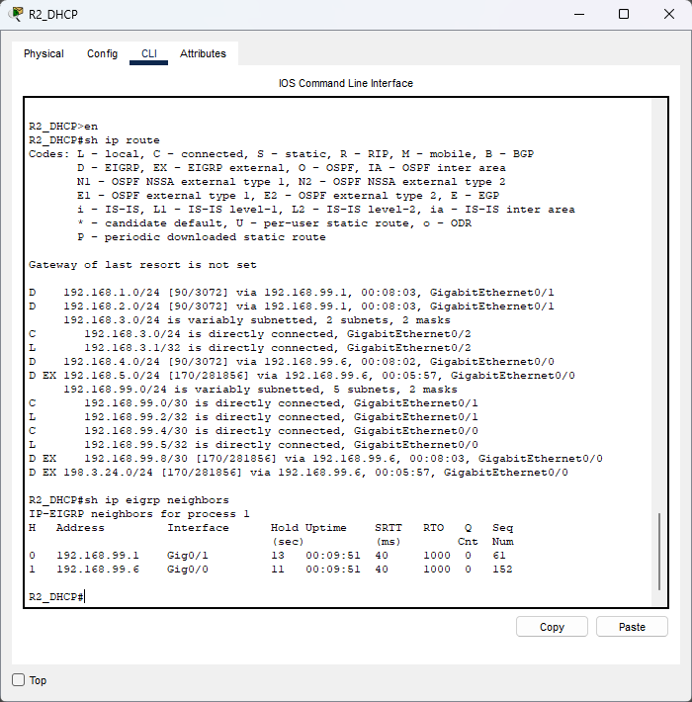 | 3
- Configure OSPF on the exterior routers (R3 gets both protocols)
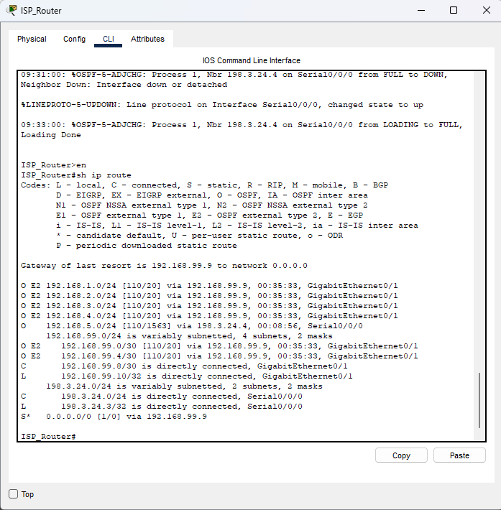 | 3
- Configure route redistribution on R3.

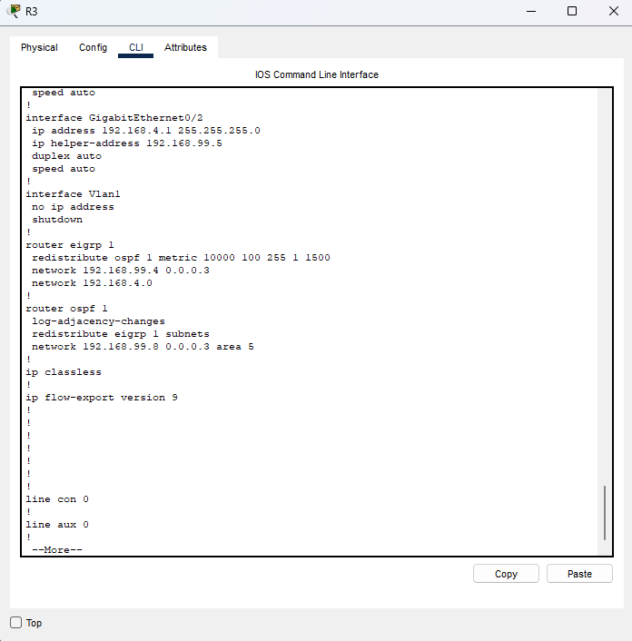 | 1
- Confirm both OSPF and EIGRP routes on R1
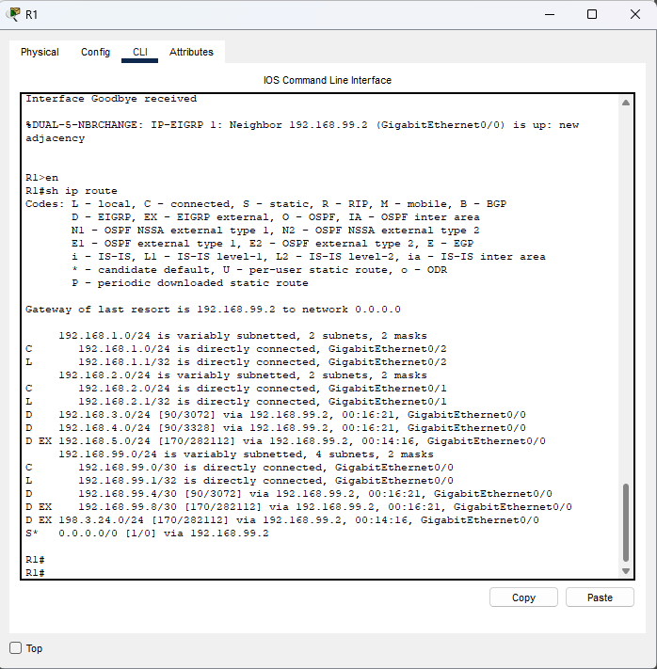 | 1
- Open the web browser on PC2 and enter www.ralph.com in the address bar.

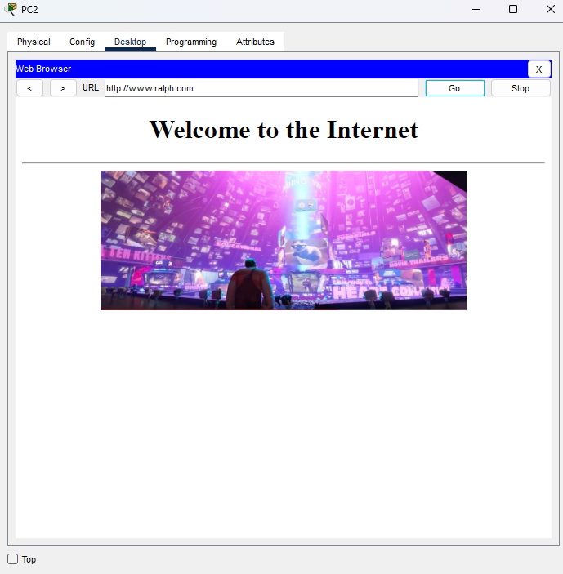 | 1
Total Points | 10

